**Kathmandu University**

**School of Engineering**

**Department of Computer Science and Engineering**

PROJECT REPORT ON



WICKED WILLIO

Pragati Manandhar (36)

Uttam Prasai (42)

Subash Sapkota (45)

Ankita Sharma (48)

Pratiksha Shrestha (53)

Prashant Subedi (57)

January 5, 2016

# ACKNOWLEDGEMENT

It is our privilege to express our sincerest regard to our project supervisor, **Mr. Pankaj Raj Duwadi**, for his appreciable guidance, encouragement, valuable inputs and productive criticism throughout the duration of the project.

We extend our sincere thanks to our project coordinator **Mr. Sushil Nepal**, for allowing us to carry on our project “Wicked Willio” and providing necessary environment to continue with our project.

We would like to thank **Department of Computer Science and Engineering (DoCSE)** and the whole university for providing us a chance to work on the project.

# ABSTRACT

With the increasing android users, android games have been one of the most demanded apps among all. Games are not only entertaining but also help in logic building. Keeping these visions in mind we are developing an android game.

This game “Wicked Willio” is an adventure-game where the main character “Willio” has to been turned into a banana. Now to restore himself, he must collect sufficient points and survive at the same time.

Table of Contents

ACKNOWLEDGEMENT I

ABSTRACT II

1. History 1

2. Objectives: 1

3. Features: 2

4. Motivation for the project: 2

5. Scope 2

6. Case Study 2

Literature Review 3

Android OS 3

Android IDE 3

Eclipse 3

Android Studio 3

Java 4

Image Manipulation 4

GIMP 4

Photoshop 4

SYSTEM ANALYSIS AND DESIGN 5

System Overview 5

METHODOLOGY 6

DEVELOPEMENT TOOLS 7

Programming tools: 7

Drawing tools: 7

Documentation Tools 7

System Output 7

SYSTEM TESTING AND DEBUGGING 8

Problems and Solutions 8

Limitation 8

Future Works 8

CONCLUSION 9

Bibliography 10

1. INTRODUCTION

With more than one billion active monthly users, Android has become one of the most popular mobile platforms (Android Studio Overview, n.d.).The Linux based operating system can run on smartphones and tablets with different types of hardware. Recently, smart watches and television running on Android OS have also become popular. With such diversity and large user base, Android is a great choice for developers to reach many users.

Gaming has historically been a strong driver of technology which pushes the market forward more than any other app category or genre and will continue to spawn device upgrades for foreseeable future. Android is the well-established and widely distributed platform that many game developers have embraced. The diversity of users, in terms of age, gender, and taste, makes Android a great platform for game development of any kind (Conder, 2014).

## Objectives:

The main objectives of this project are:

* To create a game that is entertaining for diverse users who use Android.
* To create light weight 2D game.
* To bring back old style video games to Android platform.

## Features:

The features of the software are:

* Supported from android API level 13 and above.
* Attractive user friendly graphical user interface.
* Presence of Background Music.
* Adventure type game with interesting level.

## Motivation for the project:

All members of our group use Android OS based cell phones and probably the most used apps on our phones. No matter how challenging or frustrating a game is, it can be extremely helpful for logic building, for fun and for stress relieving. Now as students, we want to contribute to this popular-genre.

## Scope

As there is a large number of android games available in the market, our game will be one of the simple and interesting game in the android market. This game will be able to make people entertain. This game will be very interesting for the old time gamers who loves the classic games.

## Case Study

There are various games written for various platforms. Adventure-type games are one of those that never gets old as there are new levels to try and achieve. Games like Mario, Hill Climb Racing and such are some of the popular games.

Mario is single player video games developed by Nintendo. The main goal was to save the princess from “Koppa”, the Villain tackling different obstacles. Hill Climb Racing is an android games where the player has to collect the coins to unlock levels. Just like most of the adventurous game, this game will also have various addicting levels completing by tackling obstacles and collecting keys.

# Literature Review

## Android OS

Android is a mobile operating system (OS) currently developed by Google, based on Linux Kernel and designed primarily for the touchscreen mobile devices such as smartphones and tablets. Android’s user interface is mainly based on direct manipulation, using touch gestures that loosely correspond to real world actions, such as swiping, tapping and pinching along with virtual keyboard for text input. The history of the Android mobile operating system began with the release of the Android alpha in November 2007. The most recent major Android update is Android 6.0” Marshmallow”, which was released in October 2015. Since April 2009, Android versions have been developed under a confectionery-themed code name and released in alphabetical order, beginning with Android 1.5 “Cupcake”. The earlier versions include 1.0. Cupcake (1.5), Donut (1.6), Éclair (2.0-2.1), Froyo (2.2-2.2.3), Gingerbread (2.3-2.3.7), Honeycomb (3.0-3.2.6), Ice Cream Sandwich (4.0-4.04), Jelly Bean (4.1-4.3.1), KitKat (4.4-4.4.4), Lollipop (5.0-5.0.1), Marshmallow (6.0). Our software will support Honeycomb and later versions (Android version history).

## Android IDE

The two most popular android development platforms are Eclipse and Android Studio.

### Eclipse

Eclipse is a Java-based open source platform that allows a software developer to create a customized development environment (IDE) from plug-in components build by Eclipse members. Eclipse is managed and directed by the Eclipse.org Consortium. Although the Eclipse Platform is written in Java, it supports plug-ins that allows developers to develop and test code written in other languages (Rouse, Eclipse definition). Using ADT plugin Eclipse can be used to develop Android applications.

### Android Studio

Android studio is an intelligent code editor capable of advanced code completion, refactoring, and code analysis. It was developed and is maintained by Google based on IntelliJ IDEA (Android Studio Overview,). It is released under Apache License 2.0 (AndroidPlugin.java).

We decided to choose Android Studio because it automatically downloads all the required software like Android Standard Development Kit (SDK), which in eclipse has to be done manually.

## Java

Java is a programming language expressly designed for use in the distributed environment of the Internet. It was designed to have the “Look and Feel” of the C++ Language, but it is simpler to use than C++ and enforces an object-oriented programming model. Java can be used to create complete applications that may run on a single computer or be distributed among servers and clients in a network. Java was introduced by Sun Microsystems in 1995 and is currently version of java is Java 8 (Rouse, Java Definition). Java is the programming language used for android app development.

## Image Manipulation

Image manipulation software are needed to develop background character, obstacles and background. We have considered following software for image manipulation.

### GIMP

GIMP is an acronym for GNU Image Manipulation Program. It is a freely distributed program for tasks such as photo retouching, image composition and image authoring. It is distributed under GNU public license (About GIMP). Gimp is available for both Windows and Linux which makes it ideal for us because half our members us Windows and half use Linux.

### Photoshop

Photoshop is an image editing software developed and manufactured by Adobe Systems Inc. Photoshop is considered one of the Leaders in photo editing software. The software allows users to manipulate, crop, resize, and correct color on digital photos (What is Photoshop?). It is the most popular software for image manipulation. It is proprietary software.

# SYSTEM ANALYSIS AND DESIGN

## System Overview

# METHODOLOGY

## DEVELOPEMENT TOOLS

The following tools were used for the development of the software.

### Programming tools:

Android Studio – for programming purpose

### Drawing tools:

Photoshop and Illustrator –for drawing purpose

### Documentation Tools

Microsoft word- documentation purpose

## System Output

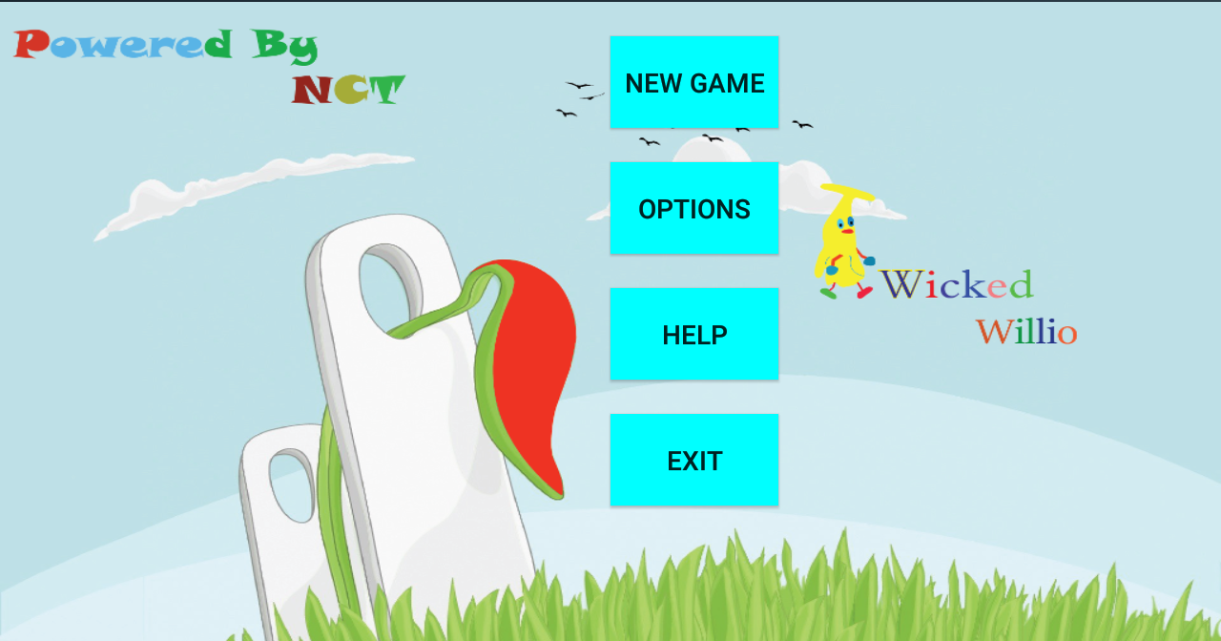

Fig: Menu Option

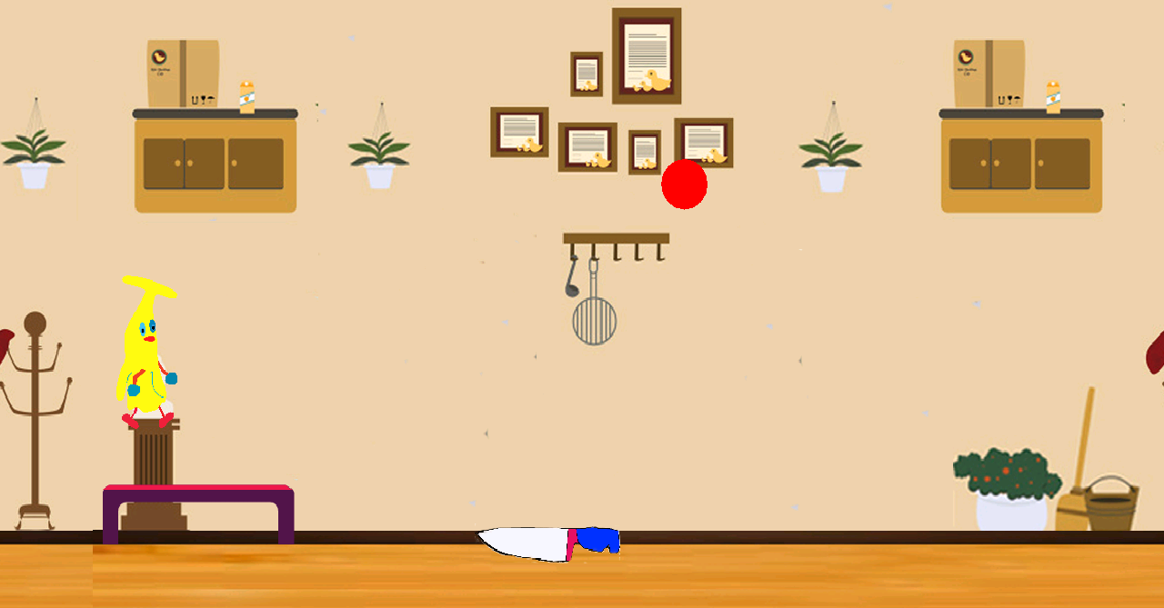

Fig: Game Play

In order to play the game, player should open the application and then click at the New game button. After that user can play the games. If any setting required regarding sound and control options, player can check the option button and help button from the main menu.

# SYSTEM TESTING AND DEBUGGING

## Problems and Solutions

Few of the major problems we faced during the project are:

## Limitation

* It will be a 2D game, not 3D.
* It does not run below the Android API 13.
* It will have only few levels.
* The game will be only Android platform based.

## Future Works

* To transport the software to Windows and others OS.
* To create more levels for the games.
* To import more features to the game.

# CONCLUSION

# Bibliography

*Android Studio Overview*. (n.d.). Retrieved December 1, 2015, from Android Developers: http://developer.android.com/tools/studio/index.html

Conder, S. (2014, May 14). *The Perfect Platform For Game Developers*. Retrieved November 29, 2015, from Developers.com: http://www.developer.com/ws/android/client/the-perfect-platform-for-game-developers-android.html